

**Name: M Shahzad**

**Class: BSDSM-F22-016**

**Section: 5-A**

### Lab 13 - Task

### Submitted To: Sir Rasik Ali

**Task 1; Implement VLAN and Inter-VLAN Routing in Cisco Packet Tracer, in the network topology of LAB-7 and LAB-8**

**VLAN**

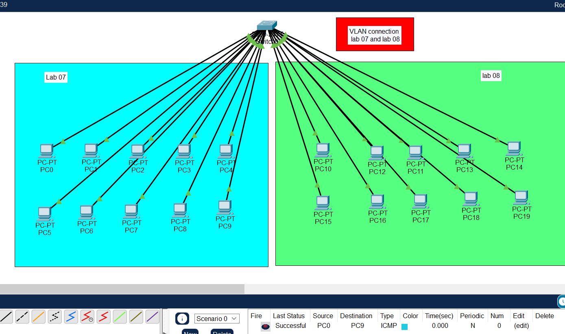

**INTER VLAN**

